How To Manage Your Team Folder Functions
Other than Player Registration

In addition to your player registration activities, the Demosphere program offers numerous options and actions you can take in managing your team via the team folder. Let’s sign in to our sample team, PIMA, and go through the various options.

Here’s what you see when you sign in to your folder. Select the Team Folder option.

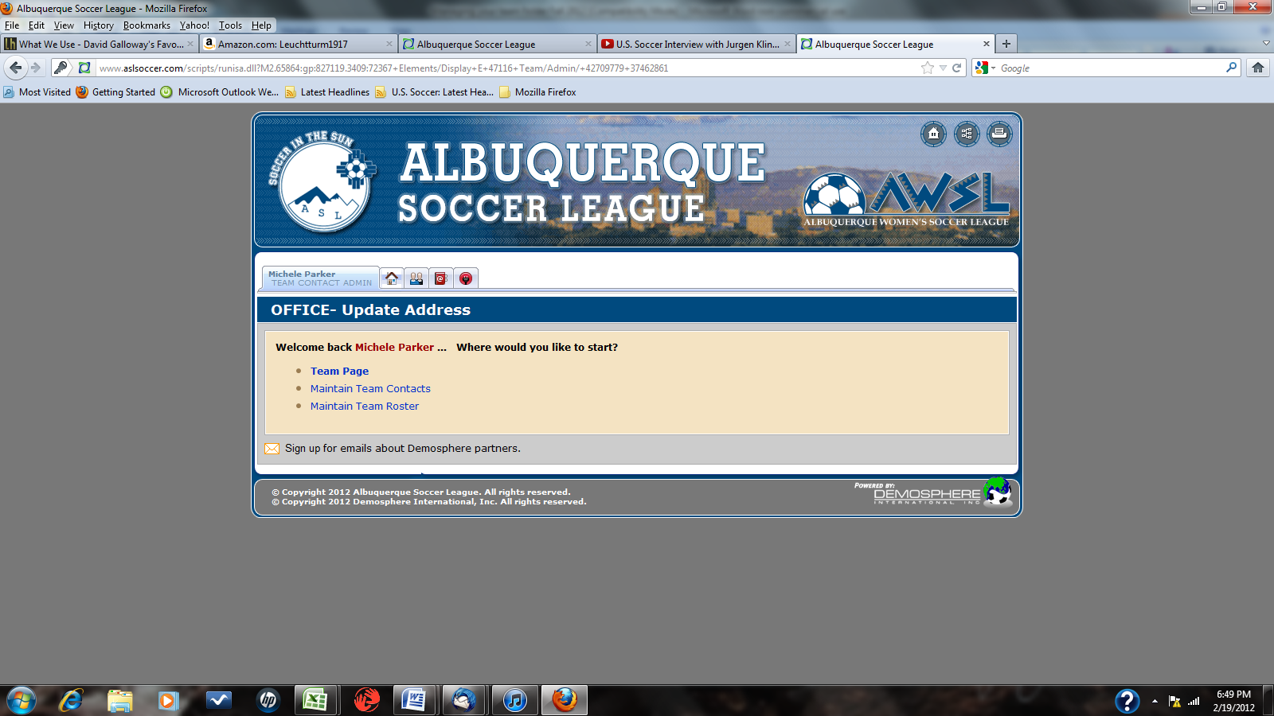

Setting up your team page display

We used to post a separate page with team rep contact info and uniform colors. Each team now controls that information. What you see when you initially click the link to your team login page is the information you want to display for anyone who needs information about your team. Click the “?” box on the right hand side and an information box will open to describe all of the various options as this article is doing.

This is the team home page that you log into:

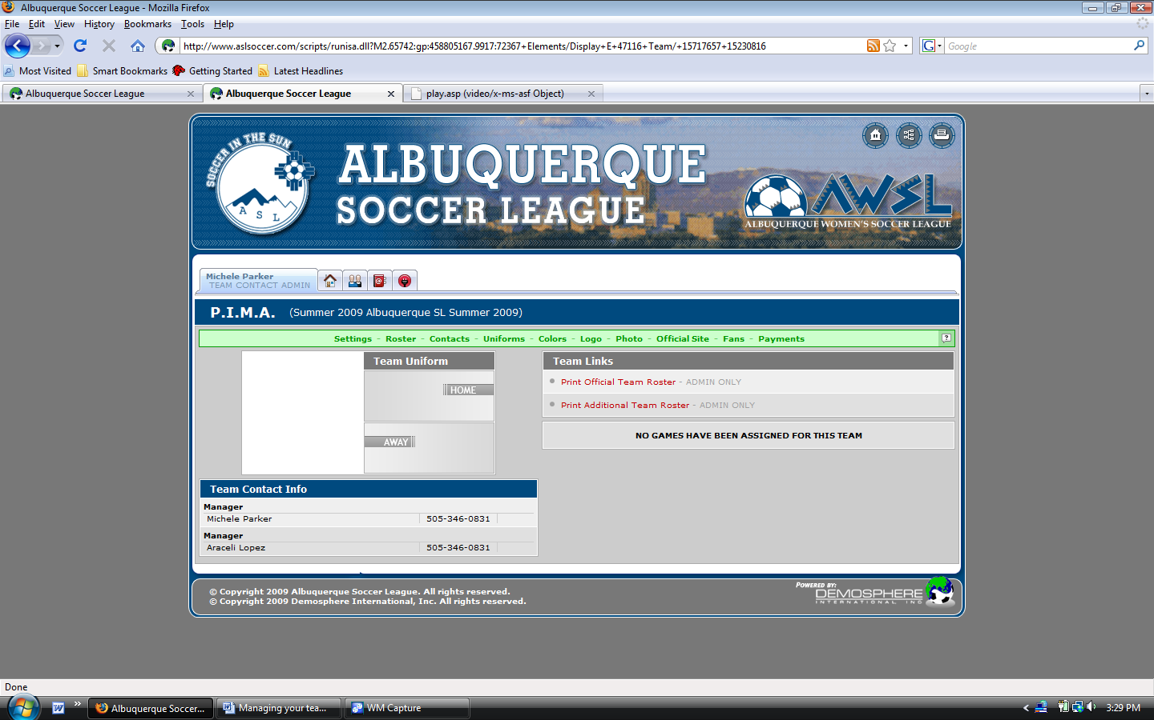

Click the Settings link on the left side of the green band and you can set up several options through these choices:

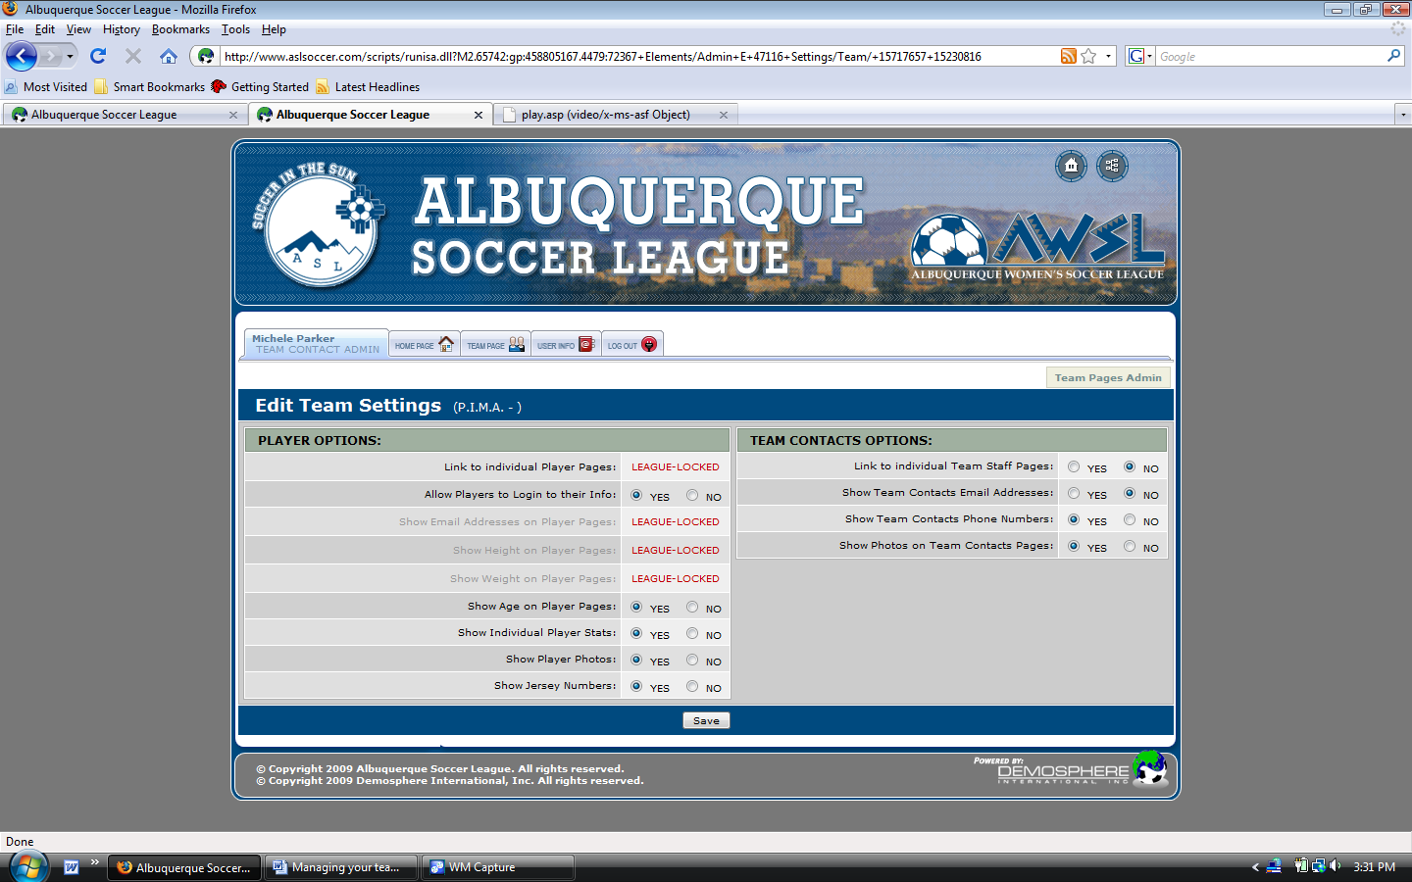

Here are your choices for your players:

There are four options you can select to allow player information to be displayed to the individual player record. The league staff will still be able to see the entire record, but certain information or the photo can be hidden.

Team contact options:

Here’s where you decide how much information you want available to the public, as anyone can see this information.

First, you can link to individual staff pages if you want someone to be able to see information on the team manager. We recommend setting this to NO.

Second, you can elect to display either your e-mail address or your phone number. We have traditionally NOT displayed your e-mail address, as some people use their work e-mail and don’t want it made available to the general public. Ditto with your phone number.

Finally, you can show a photo on the team contacts page.

Roster

This function is fairly well explained in the player registration tutorial. We’ll skip it here.

Team Contacts

Every team requires at least one team contact in order to complete the team registration process. We strongly recommend that you have at least one additional team contact. You can have as many team contacts as you want. Also, we need you to complete you mailing address information, e-mail and telephone contact information so we can contact you on behalf of the league. Bear in mind that you have to be a team contact to log in and print your game roster. Make sure you assign a role to your team contact and a PIN if you want them to be able to log in and conduct business in the team folder.

Also, when we send broadcast e-mails, they will go to everyone who is included in the Team Contacts database. For things like rainouts and general information, having more than one person receiving the message is important to make sure someone from your team receives it.

Uniforms

This function lets you select your home and alternate jersey color and design to display on your team page. This helps make the information available for other teams to see (as well as for you to see theirs) so we can avoid color conflicts at games. There is no shortage of options regarding your design and color, so please select those so everyone can see what to expect.

Colors

You can pick your favorite colors for your team page display. Yeah, OK, maybe that’s a little much, but it is available.

Logo

You can post a logo for your team. The picture size options are the same as for your player photo and you upload the same way. For example, if you check out Moosehead, you can see that they are fans of certain things from the great white north…..

Photo

You can post a team photo, as several of our winners from last season have done. Or if you like someone else’s team better, you can post their photo instead.

Official Site

If your team has a web site, and some do, this is where you post a link to your team’s web site.

Fans

Yes, you an add information about your team’s official fans.

Payments

This is where you can keep track of payments through the online payment system. It will NOT reflect payments made in person at the soccer office.

Game Rosters

On your front page, you will see two roster options.
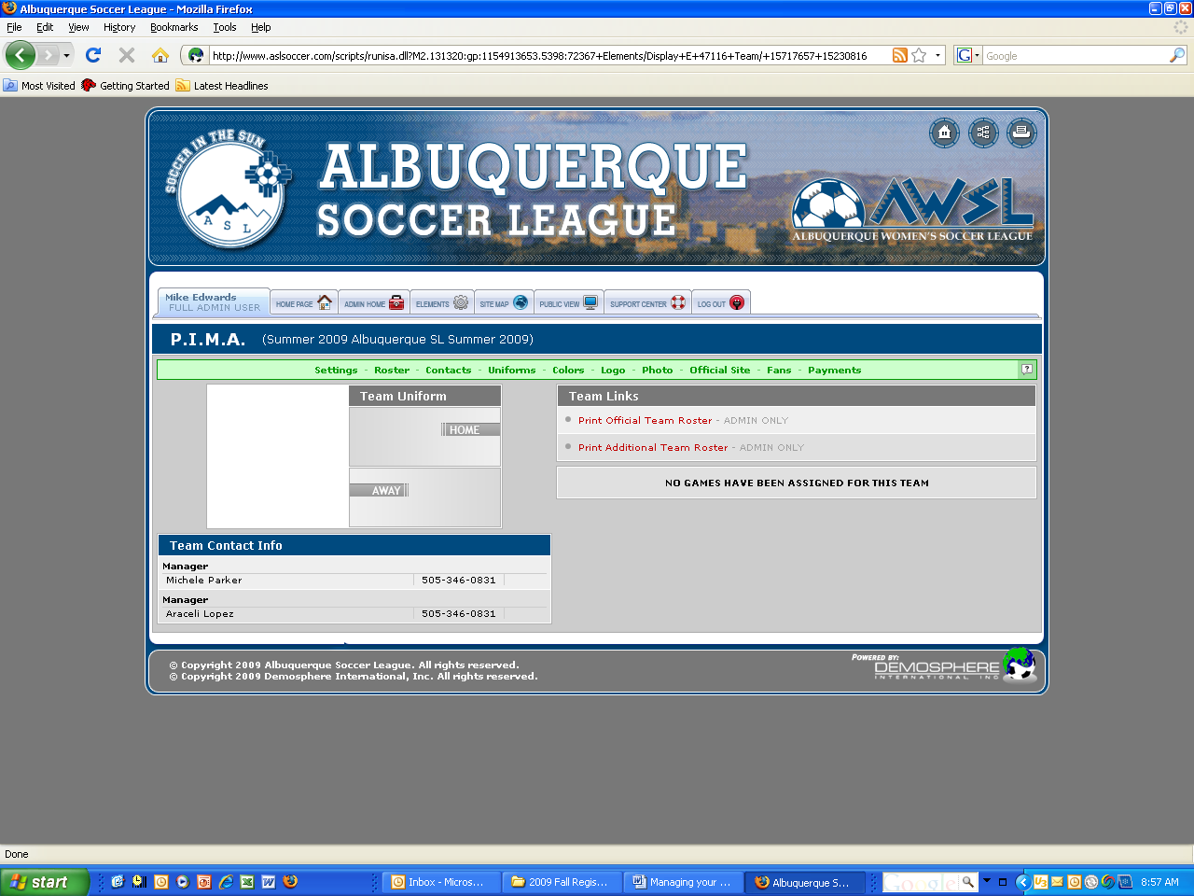

In the center of the page, you will see, highlighted in red, two links. The first is to print your official team roster. This is for the team rep and includes all of the player information. The second link is to print an Additional Team Roster. This link takes you to the official game roster to submit to the referee before the game. On your player roster function (click the Roster link in green) you can enter a jersey number for each player. That jersey number then prints on your official game roster, saving you time of inserting those numbers by hand.

